Full name: ……………………………….
EXERCISE No.1
I/ Look at the pictures and letters, and then write the words.
 ----
a c
f e

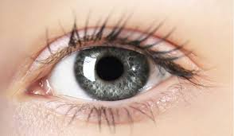 ---
y e
e

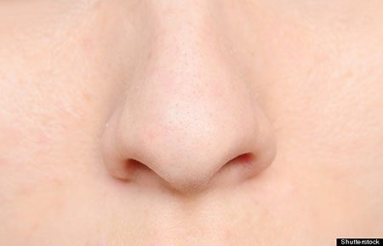 ----
o s
e n
o h
t m u
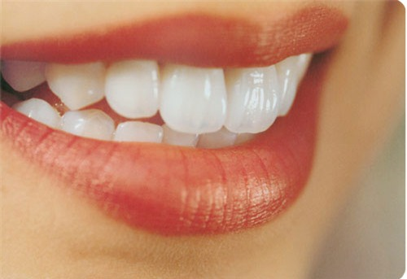 -----
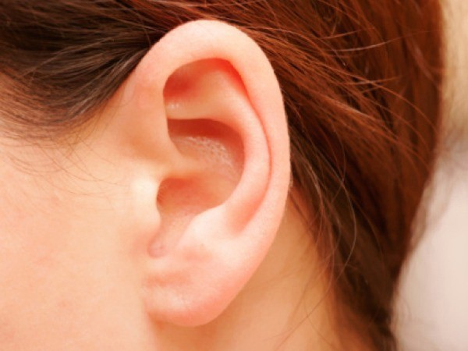 ---
a r
e
 ----
a h
d n

 ---
t e
f e
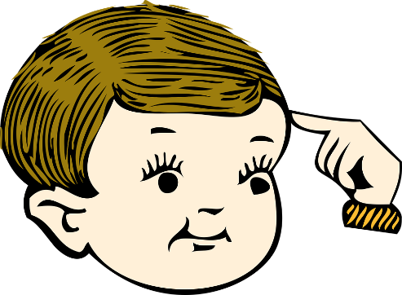 ----
a e
h d
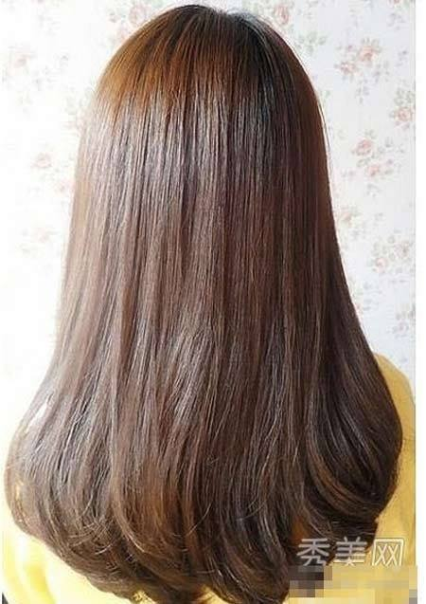 ----
a i
h r
 ------
n i g
f e r

II/ Use “a” or “an”
1/ ................... apple
2/ ................... ball
3/ ................... door
4/ ................... elephant
5/ ................... ruler
6/ ................... eraser
7/ ................... umbrella
8/ ................... oval
9/ ................... tiger
10/ ................... ink
III/ Write down one word which starts the given letter
1/ a...................
2/ b...................
3/ c...................
4/ d...................
5/ e...................
6/ f...................
7/ g...................
8/ h...................
9/ i...................
10/ j...................
11/ k...................
12/ l...................
13/ m...................
14/ n...................
15/ o...................
16/ p...................
17/ q...................
18/ r...................
19/ s...................
20/ t...................
21/ u...................
IV/ Rearrange these words
1/ pen / it / a /. / is …………………………………………...
2/ this / what / is / ? …………………………………………...
3/ is / an / it / orange / ? …………………………………………...
4/ I / not / , / no / am / . …………………………………………...
5/ it / is / ? / what …………………………………………...
6/ name / your / ? / what / is …………………………………………...
7/ is / name / my / Ann / . …………………………………………...
8/ doctor / he / is / a / ? …………………………………………...
9/ teacher / a / is / . / she …………………………………………...
10/ an / that / ink / . / is …………………………………………...
V/ Missing letters
1/ S…nd…y
2/ …riday
3/ S…tu…day
4/ W…dn…sday
5/ M…nd…y
6/ …uesday
7/ Th…rsd…y

Good luck!

